Lab Report

Title: Site Selection for Prairie Restoration Using SVM
Notice: Dr. Bryan Runck
Author: Lucy Sageser
Date: 12/19/2023

Project Repository: <if applicable weblink to public repository>
Google Drive Link: <if applicable with data, notebooks, etc.>
Time Spent: Over 100 hours

Abstract

For this project, I will explain the goal of creating a support vector machine that will provide a ranked recommendation of the best parcels in Dakota county to acquire for the purposes of restoring native prairie. I’ll explain the data used, how the support vector machine works, and provide a data flow diagram showing the entire process. Data verification will be explained by comparing the results of the SVM selection to how the parcels ranked on a simple weighted linear combination and analyzed using a confusion matrix. Overall discussion on the results and conclusions will be presented at the end.

Problem Statement

Over the course of the last two centuries, the percentage of land in Minnesota that could be classified as native prairie land has declined from nearly a third of the state to less than one percent of its land (Chaplin, 2023). The presence of native prairie land provides numerous environmental benefits, such as erosion control and reduced flooding risks, natural carbon-capture, supporting native fauna, and providing a habitat for native pollinator species (Chaplin, 2023). In order to combat the decline of native prairie lands, government conservation agencies such as the US Fish and Wildlife Service will purchase land parcels to convert them into restored native prairie ecosystems. The goal of this project was to create a tool for these realty acquisition specialists that would recommend ideal land parcels to acquire and convert to prairie based on factors such as cost per acre, land use type, and parcel distance from existing native prairies and government conservation land. This tool would use a Support Vector Machine trained on datasets of ideal and non-ideal parcels for prairie restoration so it could then identify ideal parcels on its own.

Table 1. Requirements
# | Requirement | Defined As | (Spatial) Data | Attribute Data | Dataset | Preparation
1 | Localize parcel and prairie data to Dakota County | Take input datasets and clip them to our area of interest (Dakota County) | County Boundaries in Minnesota  Minnesota Parcels  MNDNR Native Prairies | County Name | County Boundaries  Minnesota Parcels  Native Prairies | Call datasets via Minnesota Geospatial Commons API, export out Dakota County from county boundaries dataset, clip prairies and parcels to the dakota county layer.
2 | Create pandas dataframe containing relevant attribute information for training SVM | Create a dataframe that contains information for each parcel about the three factors we are training the SVM to focus on (land use, dollars per acre, and proximity to native prairies or FWS/DNR conservation land) | Minnesota Parcels  MNDNR Native Prairies | useclass1  acres_poly  emv_total  owner_name | Minnesota Parcels  Native Prairies | Convert MN parcels and MNDNR prairies attribute data to numpy arrays, convert parcel land use fields to integer values, iterate through parcel owner name field to identify all parcels owned by FWS or DNR and add all other parcels to prospective parcels, apply masking array to identify prospective parcels from FWS/DNR land, calculate centroids of prospective parcels, FWS/DNR parcels, and prairies, use scikit learn’s nearest neighbor function to calculate centroid distances from prospective parcels to prairie and FWS/DNR centroids, then calculate dollars per acre value of prospective parcels and add all prospective parcels to pandas dataframe.
3 | Create Positive and Negative Training Data | Select ~200 parcels that exemplify the characteristics we desire for prairie restoration (low dollar per acre value, agricultural and exempt land use types, and close proximity to native prairies and FWS/DNR land) as well as ~200 parcels that exemplify the opposite, or traits we do not desire. | Minnesota Parcels | useclass1  costperacre  distancetoland | Minnesota Parcels | Positive training dataset parcels were selected manually through expert analysis and exported as a new positive training dataset layer. Negative training dataset parcels were gathered by randomly selecting 25 parcels at a time, reviewing them manually, and removing those that had attributes in common with ideal prospective parcels through expert analysis. Remaining parcels were added to the negative training parcels and process was repeated until ~200 negative parcels had been selected, then selection was exported as negative training dataset layer.
4 | Create, Train, and Execute Support Vector Machine | The prospective parcels and training data need to be prepared for the SVM so that it can identify the training data, know which attributes to focus on and consider, and then the SVM will select its top and bottom 100 parcel picks for restoration. | Minnesota Parcels | useclass1  costperacre  distancetoland | Minnesota Parcels | Specify which fields we want the SVM to consider when classifying parcels, load training data into numpy array and search the parcels for the training parcels, remove NANs from data and reformat indexes, apply masks to positive and negative training parcels and associate them with prospective parcels, generate the SVM training data from the masks, normalize training data using fit and transform method, create Principle Component Analysis (PCA) plots and simplify data using PCA, pass data through the SVM to separate it out, add a field for the SVM confidence score and export out 100 parcels with highest confidence score and 100 parcels with lowest confidence score
5 | Create Weighted Overlay for Data Verification | Selection criteria data was converted to raster formats and used for a weighted overlay using equal weights so that the parcels returned by the SVM could be compared to their weighted overlay scores to assess SVM selection accuracy. | Minnesota Parcels | useclass1  costperacre  distancetoland | Minnesota Parcels | The dakota parcels layer was converted into three raster datasets based off of land use, cost per acre, and the distance to nearest native prairie or FWS/DNR land and each raster layer was reclassified into integer values. Then all three rasters were passed through the weighted overlay tool and given equal weights to produce a raster of the weighted scores.

Input Data

Table 2. Data Sources
# | Title | Purpose in Analysis | Link to Source
1 | Minnesota Counties | Used to focus other data sources to our interest area of Dakota County | County Boundaries
2 | MNDNR Prairies | Used to find the proximity of prospective parcels for acquisition to existing prairie lands | Native Prairies
3 | Minnesota Parcels | Used for the bulk of the data; This provided the specific information for all the parcels in the area of interest that we want to assess for potential acquisition and prairie restoration. | Minnesota Parcels

Methods

In order to provide recommendations of ideal parcels for prairie restoration in Dakota County, I have elected to use a Support Vector Machine (SVM) with a Radial Basis Function (RBF) kernel, all of which relies on Principle Component Analysis (PCA). I will explain these concepts and how they relate to this project below:

Principle Component Analysis, or PCA:

Principle Component Analysis is a method used to reduce the dimensions of variables in complex data in order to identify distinct groups, patterns, and variability within a dataset, with the axes representing the principle components of variation within the data. It is useful for our purposes because it reduces the complexity of the data variables in our model so that our machine learning support vector machine can interpret distinct groups of parcels that match our conditions and groups that do not.

The first step in PCA is centering the data. The mean of all the relevant variables that are being observed is determined (in our case, distance from key features, price per acre, and land type), and that mean is subtracted from each parcel’s variable values for those features. Then the covariance matrix is calculated for each of the centered data points, which helps to provide information about the relationships between the different variables being examined. Then, something called the ‘eigenvectors’ and ‘eigenvalues’ are determined based off of the covariance matrix. ‘Eigenvectors’ are the direction of the most significant, or maximum variance in the data, while ‘eigenvalues’ represent the degree of variance along each directional eigenvector. The eigenvectors are ranked in order of highest eigenvalues, and the eigenvectors with the highest eigenvalues form the principle components, because those are the directions that the data shows the most variation. Finally those principle components can be plotted in a two-dimensional graph, and the separable classes within the parcel data can be observed.

Support Vector Machine, or SVM, using a Radial Basis Function, or RBF, kernel:

A Support Vector Machine is a kind of machine learning tool that attempts to draw a line or plane called a ‘hyperplane’ that divides separable classes of PCA data into distinct, identifiable groups. The hyperplane is drawn in such a way to maximize something called the ‘margin’, which is the distance between the plane and the nearest points in each class you are trying to separate. These nearest points are called the ‘support vectors’.

When the data is difficult to separate with a simple linear plane, something called a ‘kernel’ is used to perform mathematical operations on the data points that increases the dimensions of the data so that a hyperplane that maximizes the margin between the support vectors can be drawn. The type of kernel used to find the ideal hyperplane for this project’s SVM is a Radial Basis Function (RBF) kernel, also called a Gaussian kernel. It measures the distance between data points to determine their similarity, and is able to draw a nonlinear hyperplane between separable groups of data, allowing it to observe more complex relationships in our data. The equation for the RBF is as follows:

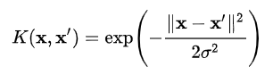

x and x1 represent the data points, ||.|| represents the distance between data points, and σ is the parameter that controls the Gaussian distribution’s width. The less distance between the points, the greater their similarity. In this way, the RBF kernel functions in a similar fashion to a weighted nearest neighbor model for PCA data.

Data Flow Diagrams:

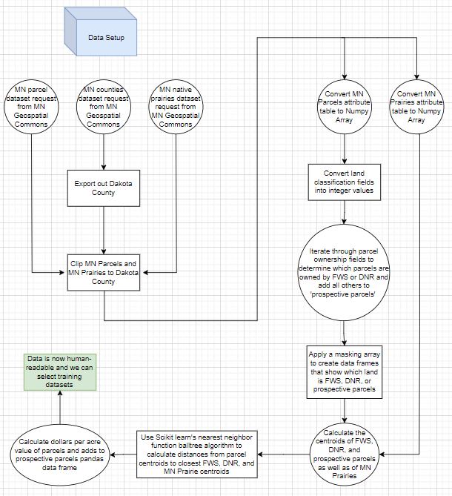
Figure 1: Data Setup

The first data flow diagram shown in Figure 1 documents the process of setting up and preparing our data for training datasets to be created from it. The relevant parcel and prairie data needed to be called and clipped down to our area of interest, Dakota County. The parcel data had to have its land classification attribute fields converted into integer values that could be processed in a numpy array, and the parcel ownership field had to be iterated through to search for those that were owned by either the US Fish and Wildlife Service or the Minnesota Department of Natural Resources. We wanted to treat parcels with those owners as relevant information used to identify prospective parcels for acquisition, and not as potential targets of acquisition themselves, so a masking array was applied to the numpy array that would identify which parcels were prospective acquisition targets and which were FWS or DNR parcels that would be used for classification. Then the centroids were calculated for all prospective parcels, FWS/DNR parcels, and native prairie polygons. Once the centroids were determined, we could determine the distance between all the prospective parcels and the nearest FWS/DNR parcels or native prairie polygons using Scikit learn’s nearest neighbor function. This was essential because we need our SVM to consider higher proximity of a prospective parcel to these land areas as more desirable for acquisition. Finally the prospective parcels were added to a pandas dataframe for organizational purposes and a field for each parcel’s dollar per acre value was calculated using the acreage field and the total estimated land value field so that our SVM would be able to identify the relative monetary value of each parcel. Once all of this was done, all of the necessary fields needed for our analysis was present in the data, and training datasets for the SVM could be created.

Figure 2: Creating Positive and Negative Training Data

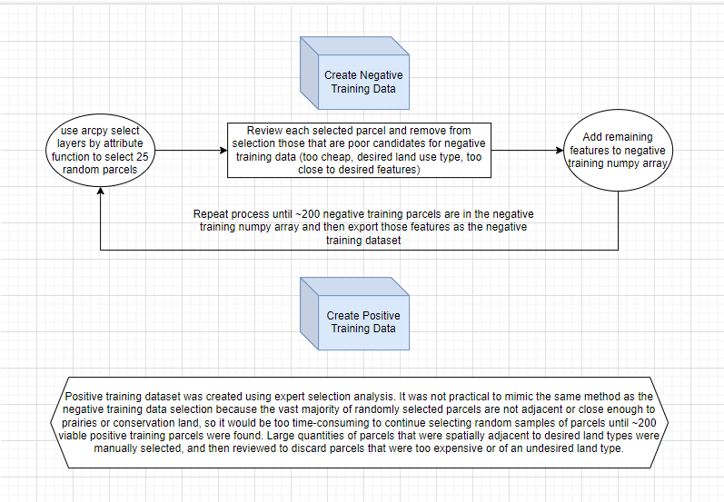

Next, we had to create two training datasets. One would be a negative training dataset which would inform the SVM of the type of parcels were undesirable for acquisition based off of their analysis variables, and another positive training dataset that would inform the SVM of the type of parcels that were desirable for acquisition based off of their analysis variables. The analysis variables of these two training datasets would be the basis of our PCA that the SVM would then delineate between. A systematic, randomized approach of gathering positive and negative training datasets was attempted to maximize the spatial variability of our data was attempted, but this proved to be too inefficient for finding positive training parcels, so an expert analysis approach was used to manually select these instead. The negative training dataset was more feasible to gather in a more randomized way, which is described in the Figure 2 data flow diagram.

Figure 3: Create, Train, and Execute SVM
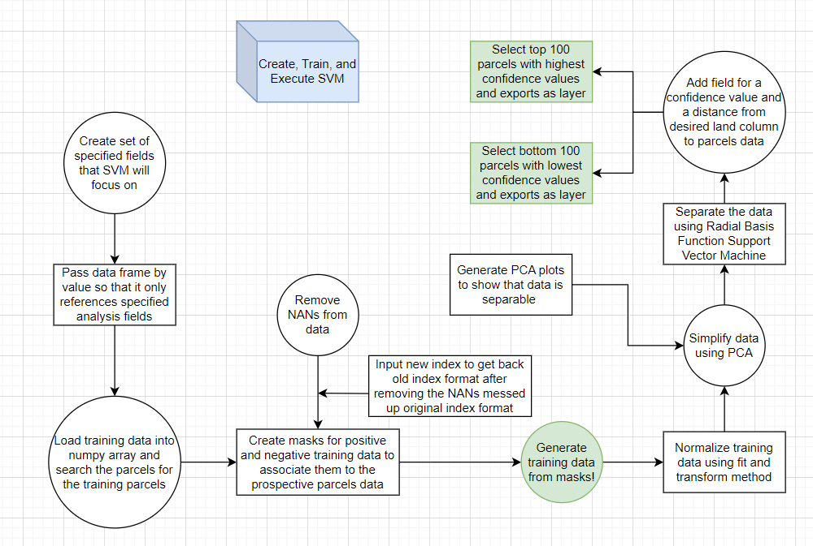
Once the training datasets were created, we specified which fields the SVM would be able to focus on by passing the pandas data frames by value so it could only reference the specified analysis fields. Masks were created to identify and associate positive and negative training parcels to the prospective parcels dataset. The training data was then normalized using the fit and transform method, and then simplified into its principle components based off of the analysis fields. The PCA was separated using the RBF SVM, and a confidence field was added to the data that represented how confident our SVM was about placing each prospective parcel into the desirable class. The top 100 parcels with the highest confidence values were then selected and exported as a layer, along with the bottom 100 parcels with the lowest confidence values. The top 100 parcels would constitute our results, and we would use them and the bottom 100 in our data verification step to assess how accurate our SVM was at identifying desirable parcels compared to a simple weighted overlay method.

Figure 4: Data Verification Setup

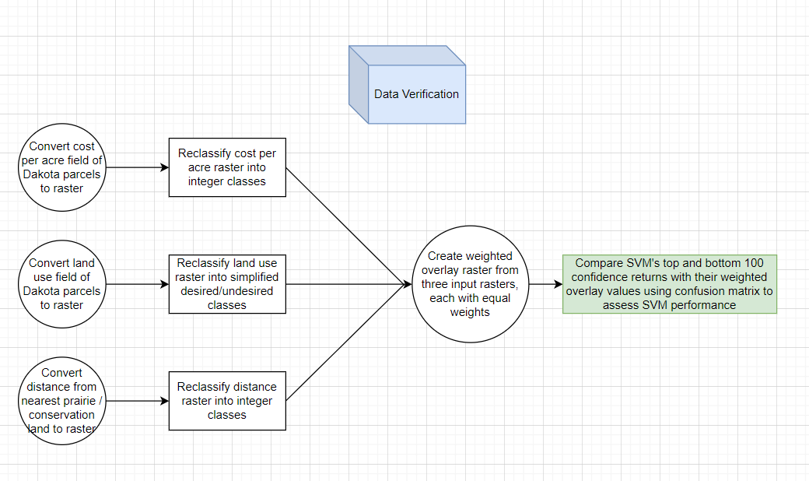
In order to assess how accurate our SVM was at identifying desirable parcels for prairie restoration, we compared its top positive and negative picks with the results of a simple weighted overlay analysis. The analysis variables of our parcel data were all rasterized and reclassified to be fed into the weighted overlay tool, which each analysis variable being assigned an equal weight. This produced a weighted overlay raster that we could layer our top and bottom 100 parcels from our SVM over to see how well the two agreed using a confusion matrix to assess SVM performance.

Results

Figure 5: Results Map

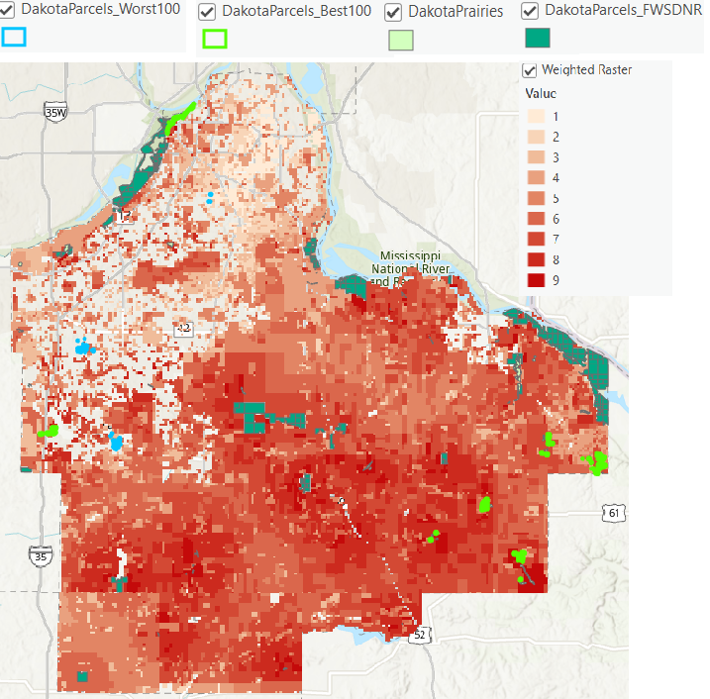

The Figure 5 map shows a general overview of Dakota County and the locations of the SVM’s top and bottom 100 picks over top of the weighted overlay raster (Darker reds are considered more desirable areas for acquisition). While land parcels owned by the FWS or DNR are more identifiable on this map, areas of native prairie are much smaller and harder to see, and many of the SVM’s top 100 parcels ended up being clustered around these locations, so a few zoomed in maps of these areas of interest will be shown below.

Figure 6.1: Areas of Interest; Top 100
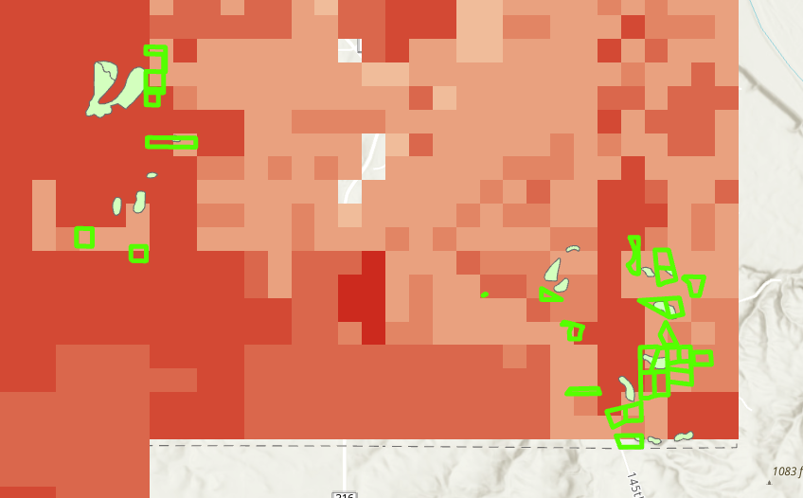
Figure 6.2: Areas of Interest; Top 100
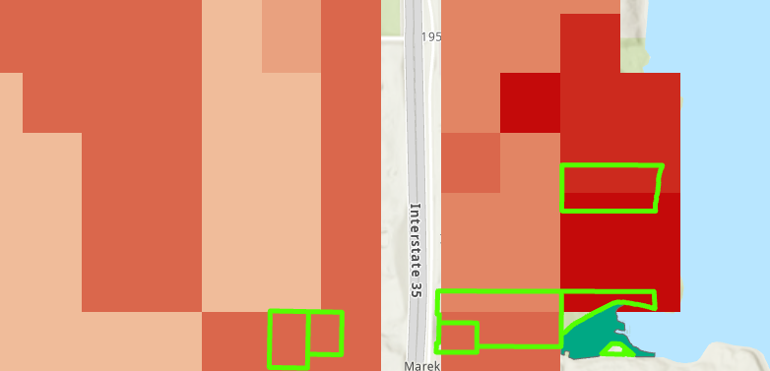

Figure 6.3: Areas of Interest; Top 100
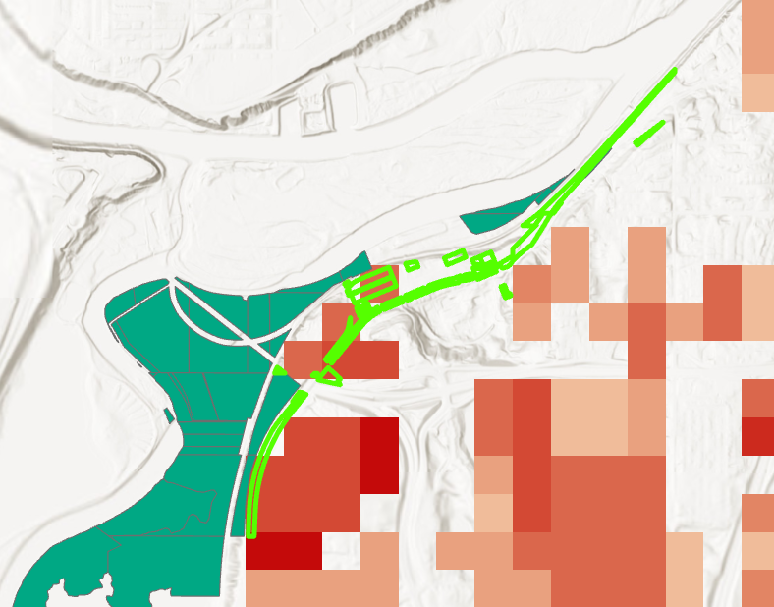

Figure 6.4: Areas of Interest; Top 100
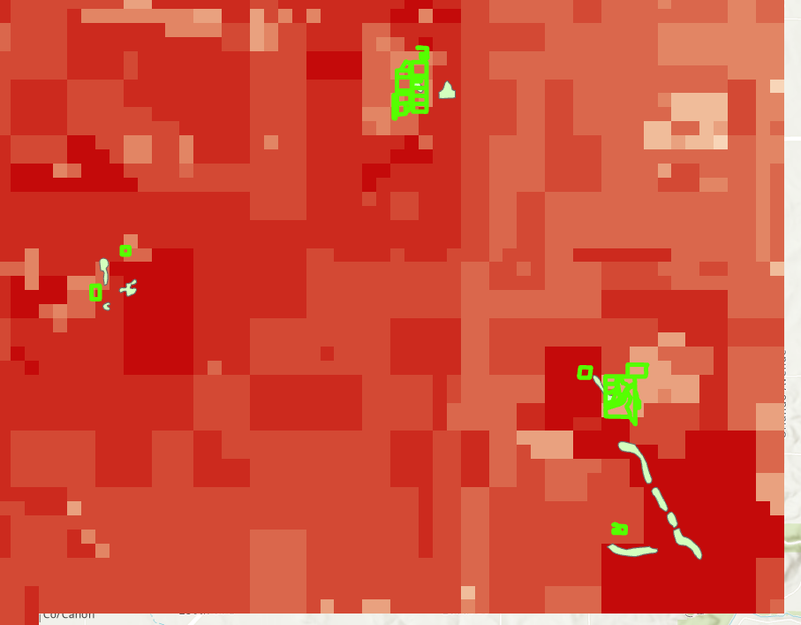

Figure 6.5: Areas of Interest; Bottom 100
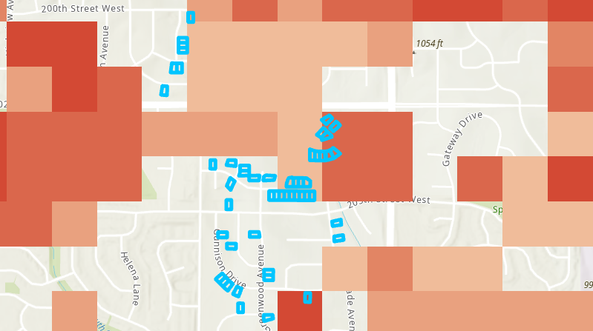
Figure 6.6: Areas of Interest; Bottom 100
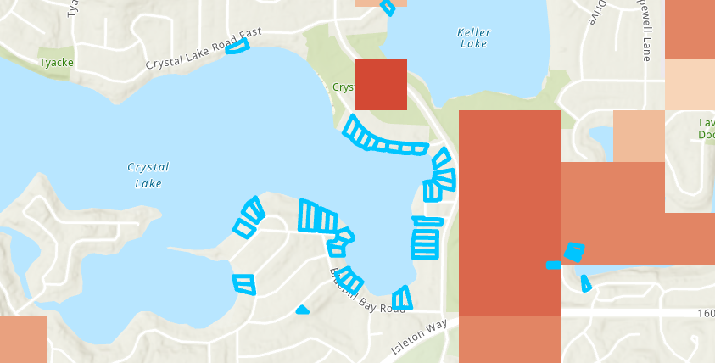

Figure 7: Price Raster; darker values represent lower costs
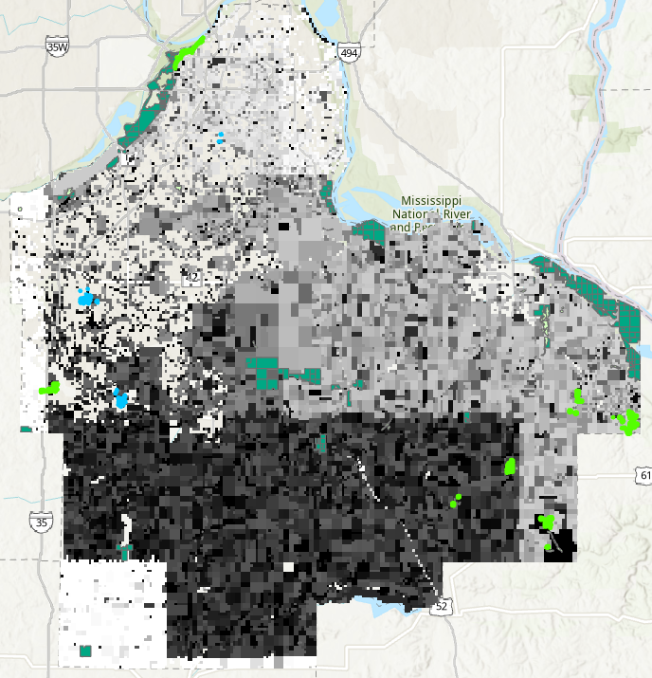

Figure 8: Land Use Raster; Orange represents agricultural and exempt land (desirable) while brown represents residential, commercial, and industrial land (undesirable)
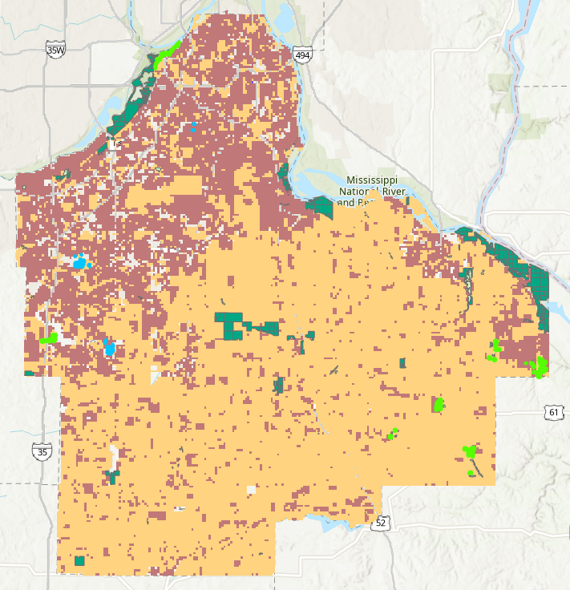
Spatially, my SVM identified parcels with high proximity to native prairies and FWS/DNR land as most ideal, and identified parcels far from those features that were high value residential plots as least ideal. However, while the parcels identified as most ideal by the SVM were generally of much lower value than the least ideal parcels, many were still decently high-value residential lots. The SVM seems to have some degree of bias towards parcels with high proximity to preferred land types and prioritizes this factor over land use type and cost. Some tweaking to the positive training data may be necessary.

Results Verification

In order to verify my results, I created a simple weighted overlay raster that equally weighed my three analysis attributes. Then, I went through all of my SVM’s top 100 and bottom 100 confidence picks and compared each parcel pick to the rank it received in the weighted overlay to create a confusion matrix. Top 100 parcels where the weighted overlay ranked it 5 or higher were counted as True Positives, while those where the weighted overlay ranked it lower than 5 were counted as False Positives. Bottom 100 parcels where the weighted overlay ranked it lower than 5 were counted as True Negatives, while those where the weighted overlay ranked it 5 or higher were counted as False Negatives. After analyzing these counts, the confusion matrix analysis resulted in the following:

TPR (Sum of True Positives divided by 100): 0.7
FPR (Sum of False Positives divided by 100): 0.3
TNR (Sum of True Negatives divided by 100): 0.91
FNR (Sum of False Negatives divided by 100): 0.09
Accuracy (Average of TPR and TNR): 0.805

Overall, my SVM appears to be a lot better at classifying undesirable parcels compared to desirable ones, but can still identify parcels desirable for prairie restoration with 80.5% accuracy. My results verification based off of this weighted overlay analysis does have some limitations, however. It turned out to be too computationally intense for my computer to produce rasters with cell sizes smaller than the default, and the default cell sizes were much larger than most parcels. Some locations in the interest area could not be assigned values at all. For areas where multiple parcels lay under a single raster cell, the value of the cell is an aggregate of the values of all the analysis attributes of each parcel underneath the cell, severely obfuscating the score of any one parcel. Therefore, the weighted overlay analysis is of dubious reliability. In the future, a weighted overlay of a finer resolution would be needed to more accurately verify the data.

Discussion and Conclusion

As discussed in the results verification, a finer raster resolution is needed to more accurately assess how well the SVM is performing at selecting desirable parcels. Until that can be done, it’s difficult to say whether or not the SVM is performing better site selection than other, possibly simpler methods. Based off of expert analysis of the recommendations the SVM is returning, I feel it is still biased towards prioritizing parcel proximity to FWS/DNR and native prairie features over other factors such as dollars per acre and land use type. I imagine this is likely a result of some bias in the expert selected positive training data; it should either be manually tweaked or a more efficient method of random sampling needs to be devised that can produce an adequately-sized subset of training parcels (roughly 200) in a reasonable time frame. Once these issues of training bias and verification uncertainty are resolved, the next step would be to see if the SVM could successfully recommend candidate parcels for prairie restoration in a county other than the one it was trained on, Dakota County.

References

Chaplin, Steve. “Minnesota Prairie Conservation Plan.” Nature.org, 2018, www.nature.org/media/minnesota/mn-prairie-conservation-plan.pdf. Accessed 19 Dec. 2023.

Cody, Paige. Guidance on Programming an SVM for Site Selection. 19 Dec. 2023.
OpenAI. (2023). ChatGPT (Mar 14 version) [Large language model]. https://chat.openai.com/chat

Self-score

Category | Description | Points Possible | Score
Structural Elements | All elements of a lab report are included (2 points each):  Title, Notice: Dr. Bryan Runck, Author, Project Repository, Date, Abstract, Problem Statement, Input Data w/ tables, Methods w/ Data, Flow Diagrams, Results, Results Verification, Discussion and Conclusion, References in common format, Self-score | 28 | 28
Clarity of Content | Each element above is executed at a professional level so that someone can understand the goal, data, methods, results, and their validity and implications in a 5 minute reading at a cursory-level, and in a 30 minute meeting at a deep level (12 points). There is a clear connection from data to results to discussion and conclusion (12 points). | 24 | 24
Reproducibility | Results are completely reproducible by someone with basic GIS training. There is no ambiguity in data flow or rationale for data operations. Every step is documented and justified. | 28 | 28
Verification | Results are correct in that they have been verified in comparison to some standard. The standard is clearly stated (10 points), the method of comparison is clearly stated (5 points), and the result of verification is clearly stated (5 points). | 20 | 20
0 |  | 100 | 100

